SCHOLARLY RESEARCH JOURNAL

Certificate
of Contribution Awarded to
Mk0 jkds'k dqekj oekZ
Has successfully contributed and published a paper
xq.koRrkiw.kZ fo'ofo|ky; ,oa egkfo|ky;% Hkkjrh; mPprj f'k{kk O;oLFkk gsrq ,d u;k vkSj Hkfo";ksUeq[kh n`f"Vdks.k
In an
Double Blind Reviewed & Refereed
Scholarly Research Journal For
Humanity Science & English Language

E- ISSN 2348 – 3083 & P-ISSN 2349-9664, SJIF 2021: 7.278
Double Blind Reviewed & Refereed Journal
AUG-SEPT, 2022 Volume 10, Issue 53, Released On 01/10/2022

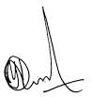

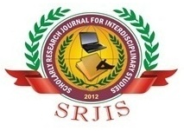
Certificate No. SRJHSEL/22/22/2022
www.srjis.com
Dr. Yashpal D. Netragaonkar
Editor in chief for SR Journals

